

October 31, 2008
Inside this Issue
1 Administration
1&2 Operations
2&3 Training/EMS
3 Did You Know?
3 Birthdays
3 Looking Back
4 Upcoming Events
4 Classifieds

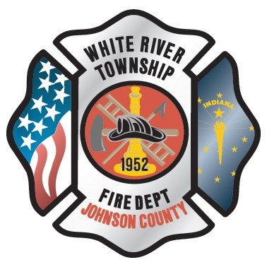 Administration News

I have been working on some Firehouse IT issues over the last two weeks. One issue was FH WEB CLIENT was not working on any of the tough books. A Microsoft download had corrupted the file and the program had to be reinstalled. The downside to the repair is that all users will have to log into the software before you can access the information. This is an extra time consuming step. I am working on correcting this in the near future. I am also working with Firehouse Tech Support on the CAD issues. Hopefully I will have answers by the end of this week or first of next week.

All of the new employees have been entered into the computer and have access to email, Firehouse and other server programs. Please welcome these individuals and help them become acclimated to the White River Twp. Fire Department.

“To effectively and efficiently provide professional services to our community”

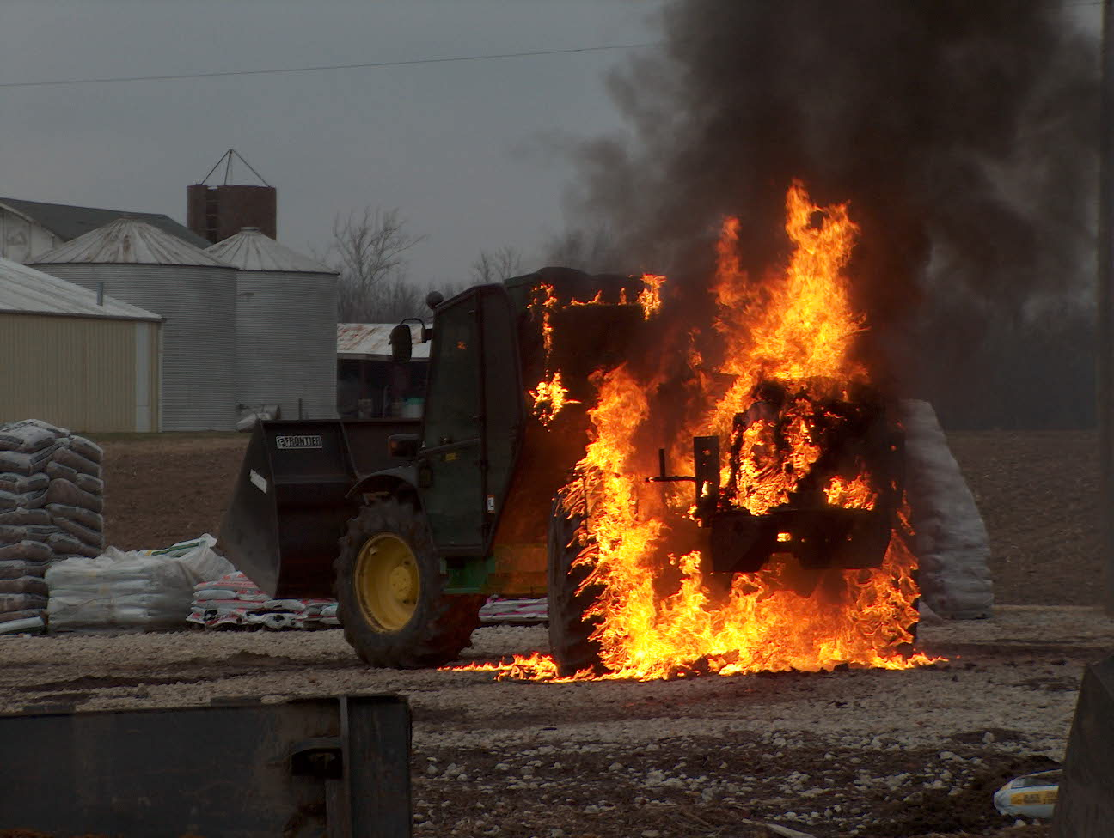 Operations News

We are still having some problems with incident report documentation. Please watch the following areas:

- Zip codes-North of Smith Valley Road is 46142 and south is 46143
- Use the F2 key to input the street address, even if Fire Control already has put it in the screen. These street names must be put in the same way every time.
- Use spell check. There are several spelling mistakes in many reports.
- Company officers should be auditing reports after completion to correct these mistakes.
- If the CAD interface with Firehouse Software is down and incidents are entered manually, remember the incident numbers are 08-800XXXX. The 8 must be after the dash.
Please see your Battalion Chief or me if you have questions or need some additional training.

Hose testing is schedule for November 6, 7, and 8th. Scott Wiegle is the point of contact. The schedule is listed below:
Nov 6 A shift Engine 51 and Tanker 52
Nov 7 B shift Engine 52 and Engine 55
Nov 8 C shift Engine 53 and Ladder 51
We will be conducting digital radio testing during the live fire trainings. Representatives from Greenwood Dispatch will be present. Training Chief Engmark and Engineer Combs are preparing the training session for digital radios use. Greenwood Fire Department is currently conducting digital testing. Their plan is to attempt to switch over to digital before the first of the year if testing is completed without problems. As far as MOSCAD alerting, Motorola has told the Fire Chiefs that they will do whatever it takes to fix the problems we are having. There are two individuals currently in Illinois from Greenwood Dispatch meeting with Motorola and attending training courses. I will have more information next week. Be Smart and Stay Safe

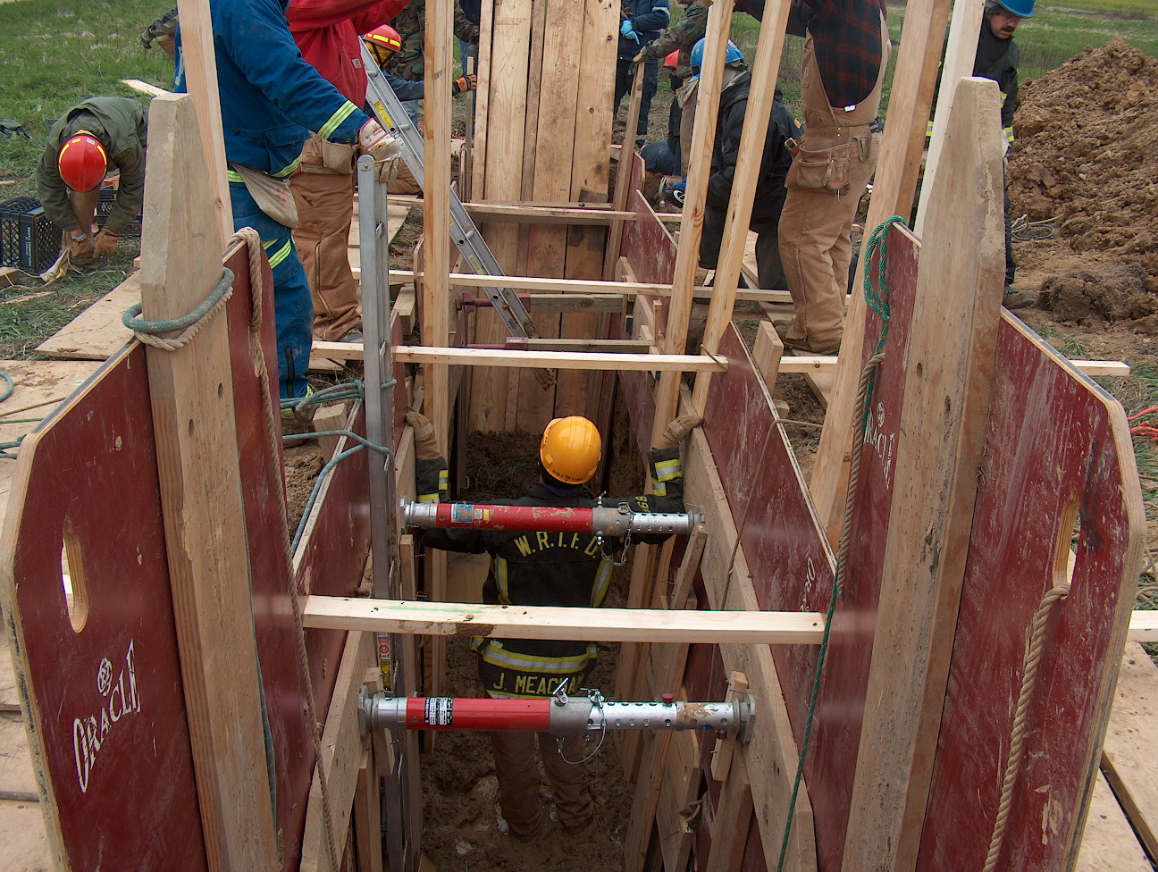 Training/EMS News

We are gearing up for the NFPA 1403 burns that will be coming up November 10th, 11th, and 12th. The shift training officers will be finalizing things to get the house ready for us to burn. Thank you to everyone who has already started getting things ready. I will have a list of things that need completed and will pass that on to the shift training officers. I know that cadets will be doing some more of the work and we extend a big thanks to them as well for helping out. We will be burning those three days from 9AM to about Noon or so. Chief Slauter has worked out the details for the SCBA companies to be there as well to test air packs. We will need some extra hands on the weekend before the burns to get the shingles off of the roof so anyone that can help would be greatly appreciated.

Vehicle extrication went well with the cars that we had at McCarty’s old mulch farm. We will get some more vehicles in the near future so that we can continue to do more extrication training.

I have been meeting with the shift training officers to come up with some different ideas and scheduling for training. We have some good ideas and we will finalize those and get those implemented by the first of the year. If anyone has any ideas or can think of anything please get with your shift training officer and get those ideas to them before we meet again in the next few weeks.

The new ALS combo boxes came in and they are the right size. I will be getting those out to the companies in the next few days. Please get with your station Captain’s and arrange these boxes and figure out what works best for you. We will also be getting a trial Glidscope unit to try out. This is a video assisted Laryngoscope. I will hopefully have it at training next week to show everyone.

We will be providing flu shots through Public Safety Medical again this year. The shots will be on November 19th, 20th, and 21st at Headquarters at 2PM. This is available to all White River Township Fire Department employees. If you need and want a flu shot please come by one of those days.
Train as if your life depends on it, because it does!
Be Smart and Stay Safe! Chief Engmark

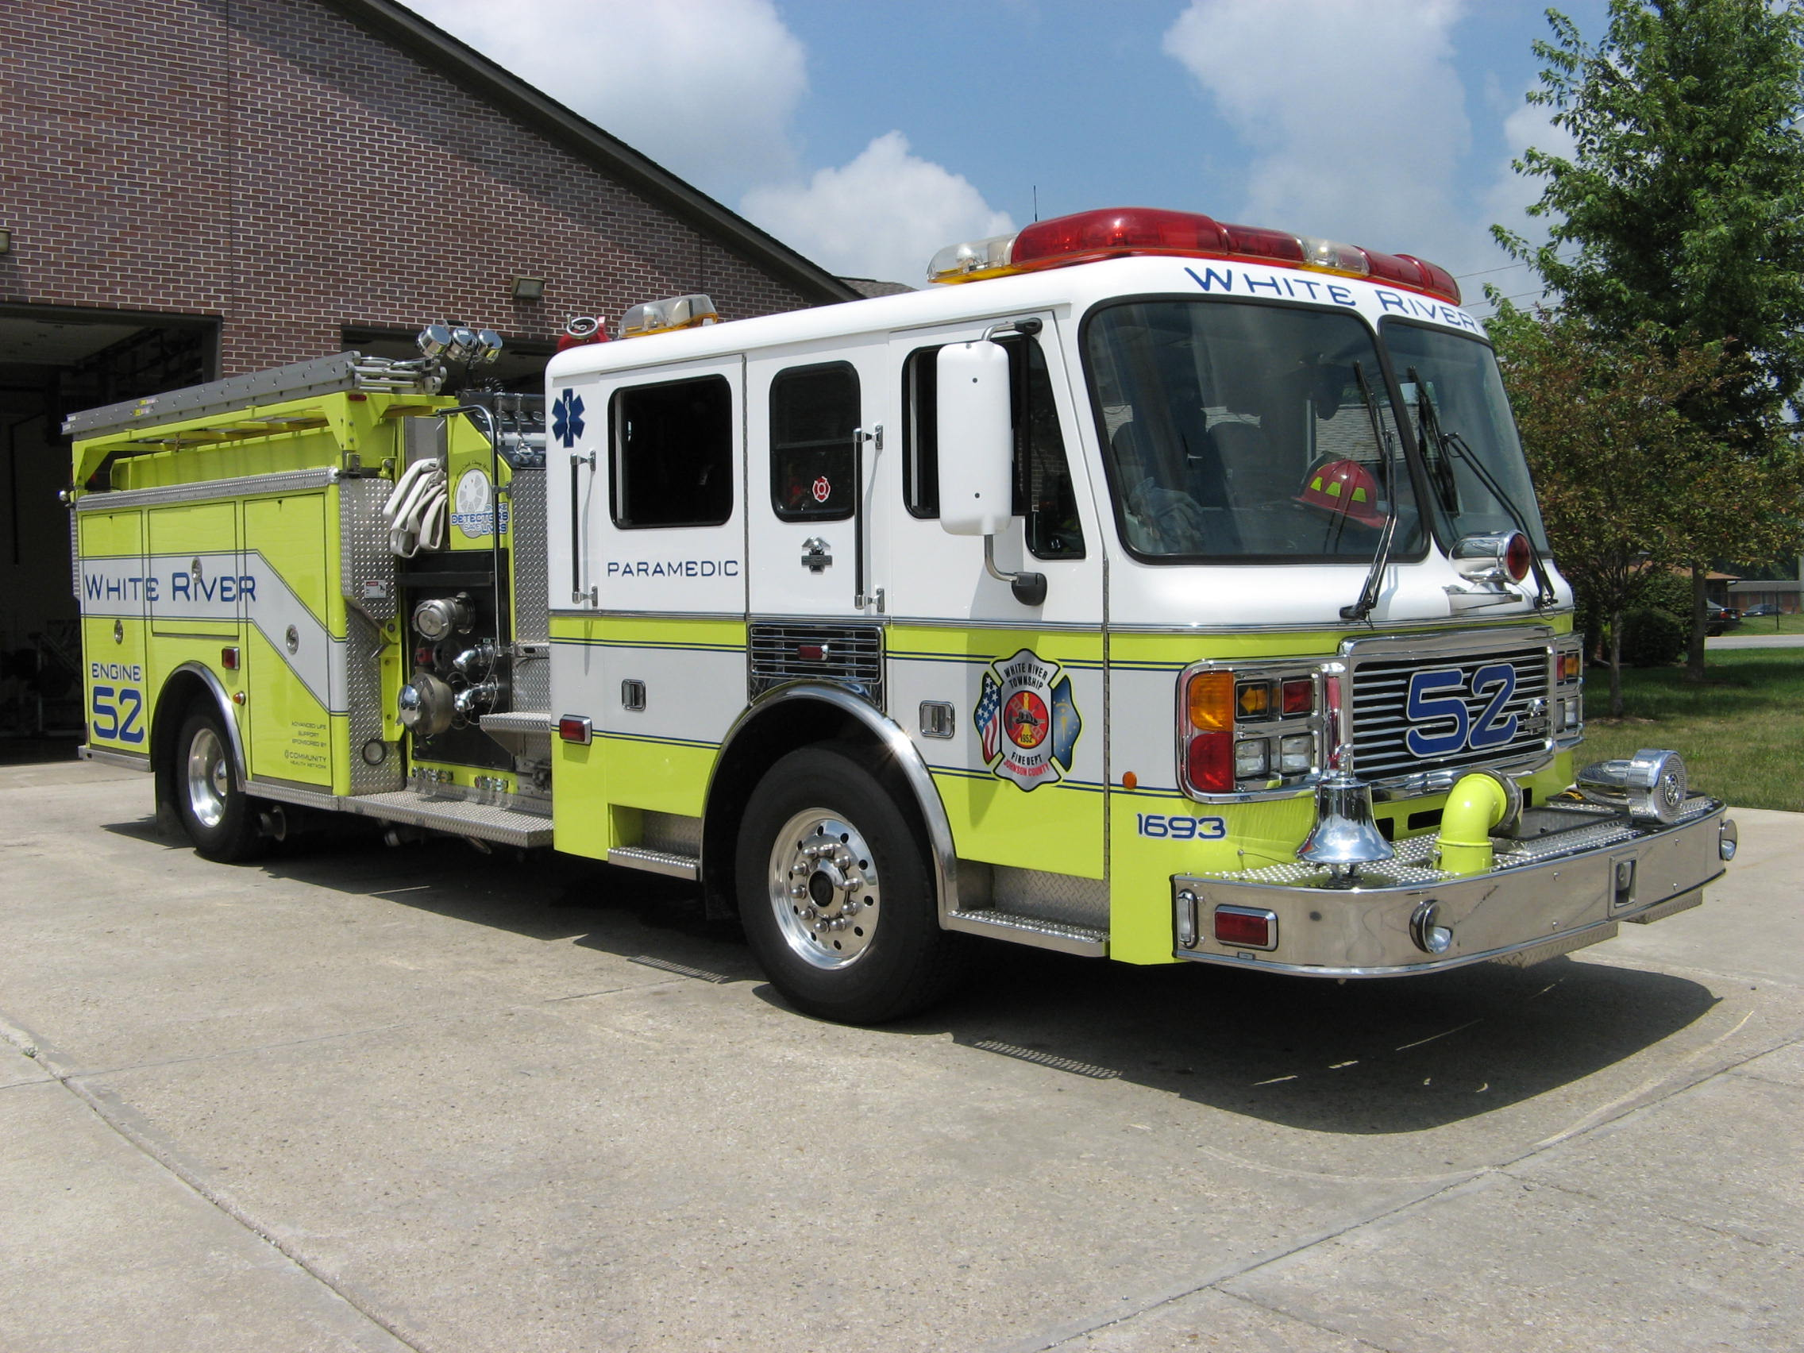 Did you know?

Did you know that Hershey’s Kisses are called that because the machine that makes them looks like it’s kissing the conveyor belt?

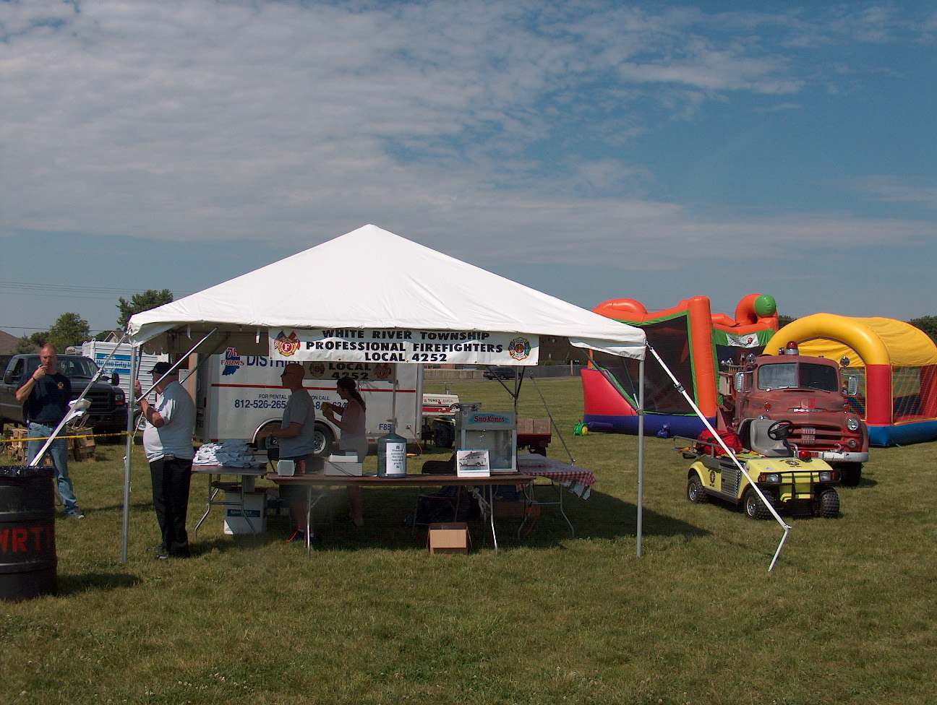 Birthdays (October 31 – November 13)

Greg Hurrle November 4 Bryan Arkins November 6

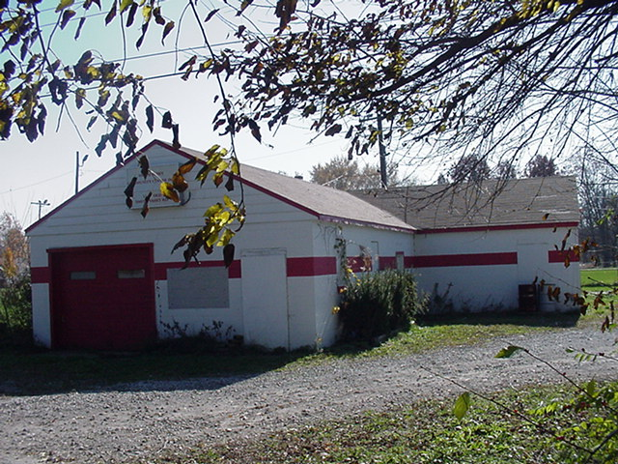 Looking back…..

23 years ago October 31, 1985 Fire guts Shady Brook trailer Investigators are still attempting to determine the cause of a midnight trailer fire in Shady Brook Heights Trailer Park that injured no one but left one man homeless. The fire, reported shortly after midnight this morning, is being investigated by the Indiana State Fire Marshal’s office and White River Township firefighters. White River Fire Chief Bob Wehrman said a one bedroom trailer at Lot 243 M Court, was gutted about 12:20 a.m. Wehrman said no one was in the trailer at the time of the fire. No one was injured, and nearby trailers were not affected by the blaze, the chief said. Wehrman said a tin of black powder used to make bullets was in the living room closet in the trailer. Wehrman said the department has not determined whether that could have caused the fire. The furnace did not explode Wehrman said, and the main part of the fire was contained in the rear of the trailer.

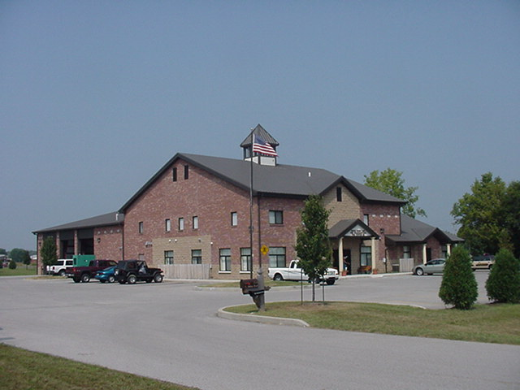 Upcoming events (November – December 2008)

Fire Protection District Board Meeting November 4, 2008 - 7pm Station 53
november 2008
S | M | T | W | T | F | S
 |  |  |  |  |  | 1
2 | 3 | 4 | 5 | 6 | 7 | 8
9 | 10 | 11 | 12 | 13 | 14 | 15
16 | 17 | 18 | 19 | 20 | 21 | 22
23 | 24 | 25 | 26 | 27 | 28 | 29
30
december 2008
S | M | T | W | T | F | S
 | 1 | 2 | 3 | 4 | 5 | 6
7 | 8 | 9 | 10 | 11 | 12 | 13
14 | 15 | 16 | 17 | 18 | 19 | 20
21 | 22 | 23 | 24 | 25 | 26 | 27
28 | 29 | 30 | 31

Classifieds

Kenmore Washer and Dryer – Electric – Excellent Condition – Cheap Price – Contact Chief Jeremy Pell 317-888-8337 Station 53.

Healthy Male Research Volunteers Wanted: IU School of Medicine is looking for healthy men to participate in a research study regarding Osteoporosis. A one- time visit lasting four hours will include: Free non-invasive Bone Density Measurement. Free Blood Sugar Screening, Free Blood pressure Check. Volunteers must be healthy males ages 20-50. You will receive $70.00 as compensation when all study procedures have been completed. For more information or to schedule an appointment, contact Paul @ 317/274-0950 or pasparks@iupui,edu

Healthy Female Research Volunteers Wanted: IU School of Medicine is looking for healthy women to participate in a research study regarding Osteoporosis. A one- time visit lasting four hours will include: Free non-invasive Bone Density Measurement. Free Blood Sugar Screening, Free Blood pressure Check. Volunteers must be healthy females ages 20-45 that are not pregnant or breastfeeding. You will receive $70.00 as compensation when all study procedures have been completed. For more information or to schedule an appointment, contact Paul @ 317/274-8433 or nwatts@iupui.edu.

